Randomness in R

# rnorm() – Generate random Normal variates with a given mean and SD

# dnorm() – Evaluate the Normal probability density (with given mean/SD) at a point/s

# pnorm() – Evaluate the cumulative distribution function for a Normal distribtuion

# rpois() – Generate random Poisson variates with a given rate (integers)

# d – density

# r – random numbers

# p – cumulative

# q - quantile

* Set the seed() to make data reproduceable

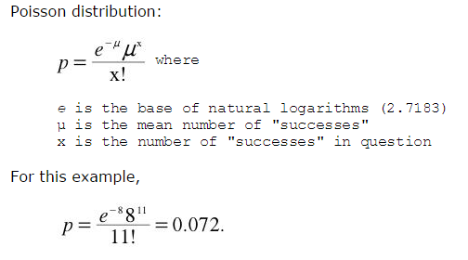

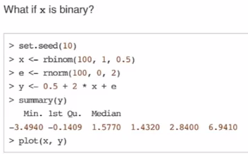

**Poisson || Binary**

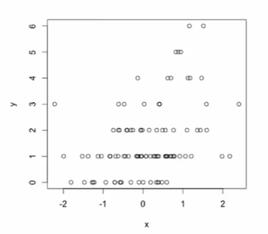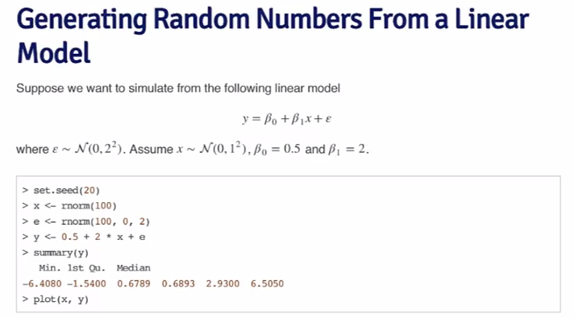

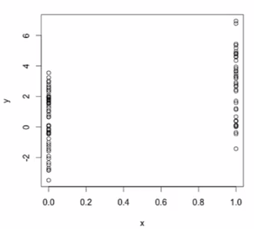

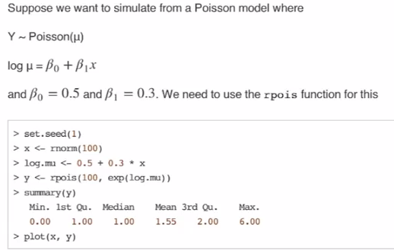

# Random Sampling – The Sample() function draws randomly from a specified set of scalar objects allowing you to sample from arbitrary distributions.

# R Profiler Systematic way to examine how much time is spent in different parts of the program. Good for trying to get efficiencies.

* Wrap in **system.time()** – how long the process in brackets takes
* System – CPU time, may be different from elapsed, if using multiple cores etc.
* **summaryRprof()** – Summarizes the output of Rprof() and gives percent of time spent in each function.
* **$by.total** – A complete look at how each part of code takes
* **$by.self** – A more granular and accurate look at what each portion of the code takes

